Excel assignment 6

***Name-Bikramjit Mondal***

***FSDA Batch***

1. ***Elements of Excel interface***

There are several elements are available on Excel interface including Quick Access Toolbar, Ribbon, Name Box, Formula Quick Menu, Formula Bar, Status Bar, Worksheet View Options, Zoom Slider Control, and the Zoom Percentage Indicator. In the below points, use of each element has been shown:

* The Quick Access Toolbar is found on the top-left of the Excel window which contains the commonly-used commands in Excel. This toolbar can be customized and lets us choose which commands we want to access easily.
* The Ribbon interface contains the commands that are available for use in Excel. This has multiple tabs including the File, Home, Insert, Page Layout, Formulas, Data, Review, View, Add-ins, and Help tabs.
* The Name Box is an input box which normally displays the name or location of the active cell on the worksheet.
* The Formula Quick Menu beside the Name box is a shortcut when user want to insert a function.
* The Formula Bar is found just beside the Formula Quick Menu. This allows you to enter or edit data, formula or a function that will appear in the selected cell whose name or location appears in the Name Box.
* The Status Bar in the bottom-left corner of the Excel window displays various information about the current mode of the workbook.

1. ***Application of Excel in industry***

Excel has been considered as the most basic analytical tools which is used in most business industry. All the major application of this tool in industry have been identified in the below points:

* In order to get a complete overview on the business operations, this tool has bene widely used by the industry experts.
* This tool enables the graphical representation of the industry data that has been generated.
* In order to manage or handle huge amount of data of company staff and employees, excel worksheet help a lot.
* Based on the analysis results and result outcome form Excel tool, sometime small organization can take crucial business decisions.
* Moreover, a complete office administration could be done by the company management by using Excel analysis.

1. ***Task on ribbon***

In this task, a new tab in excel ribbon has been enabled by using customize ribbon option. In the below screen shots, all the possible steps have been given.

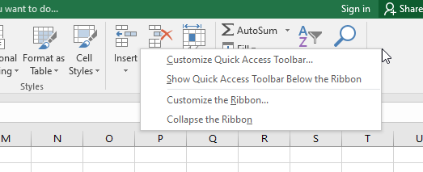

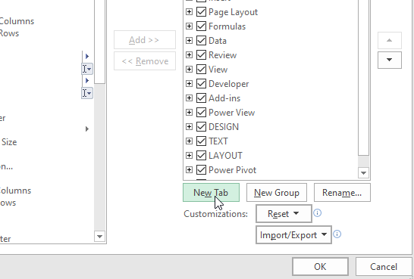

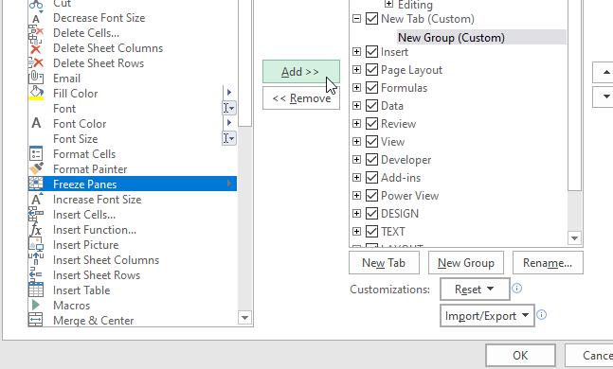

1. ***Different shortcut keys***

* Alt + F: File menu options in current program.
* Alt + E: Edit options in current program
* F1: Universal Help in almost every Windows program.
* Ctrl + A: Select all text.
* Ctrl + X: Cut
* Shift + Del: Cut selected item.
* Ctrl + C: Copy selected item.
* Ctrl + Ins: Copy selected item.
* Ctrl + V: Paste selected item.
* Shift + Ins: Paste.
* Home: Goes to beginning of current line.
* Ctrl + Home: Goes to beginning of document.
* End: Goes to end of current line.

1. ***Excel and other analytical tools***

There are several analytical tools available that are being utilized by the business professional to get insights in their business operations. Excel is one of the simples and efficient analytical tool as compared to other tools. This application is in use for last 30 years by most of the business industries. A consistency in the application update and features addition has been seen as compared to other platforms. However, programming based analytical tools are also getting popular.

1. ***Task on table***

In this section, a new table has been created and then header and footer have been added. All the necessary steps and their screenshots have been added in below section.



